Omar Ahmad

EE 180DA

Lab 1A

Week 6 report

This week I planned to finalize the plan our group was going to pursue and begin work on the algorithm used to send each agent their lighting sequence.

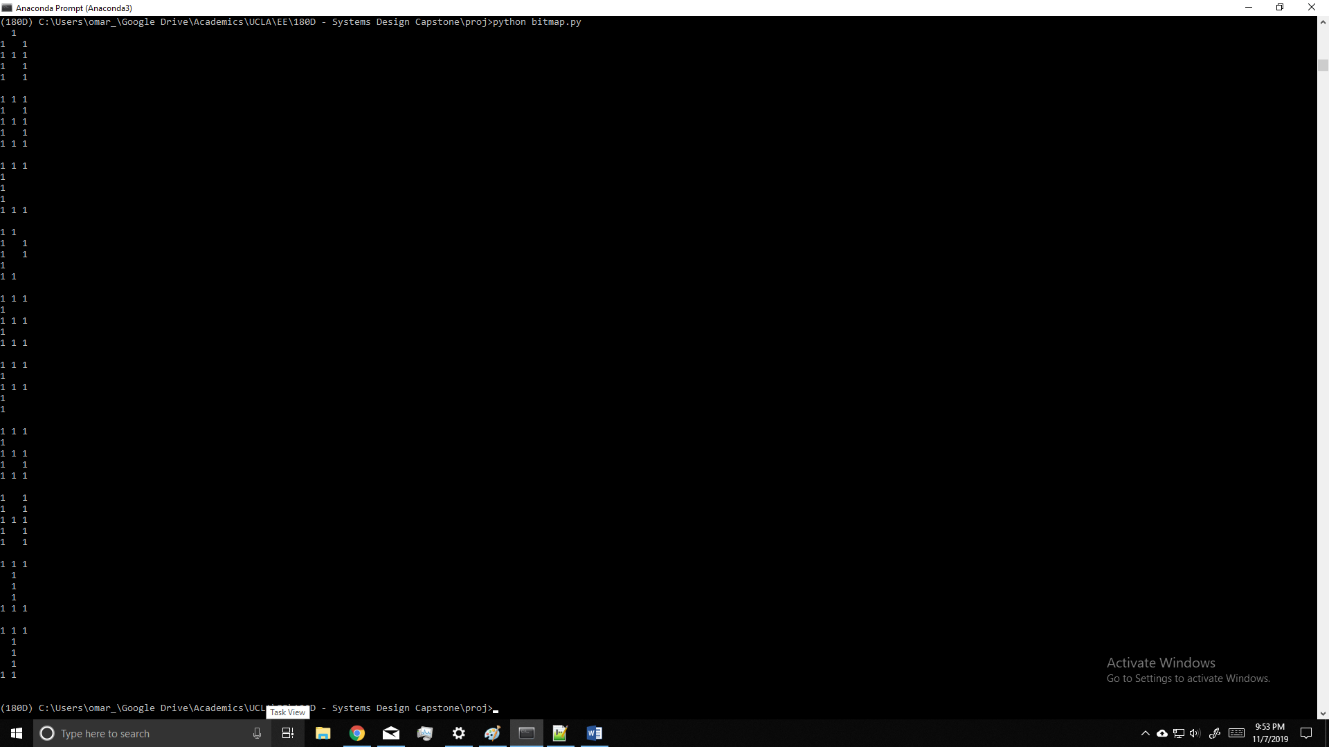I ended up not completely finalizing our plan as we are not sure if Bluetooth is the best option or if it will work at all. I did begin on the algorithm starting with a basic 3x5 bitmap of A-Z and 0-9 as a proof of concept. Currently I am working on separating out each pixel’s role for a given message.

This image is a screenshot of preliminary bitmap testing on letters A-J

A

B

C

D

E

F

G

H

I

J

In the next week I plan to further develop this algorithm and at the very least program the entire 3x5 character set. If possible, I would like to implement complete functionality of the 3x5 case so that the rest of the work would simply be manually entering char bitmaps for different potential formats